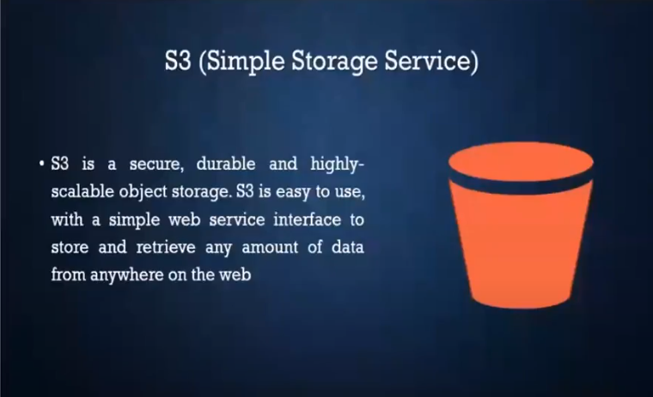

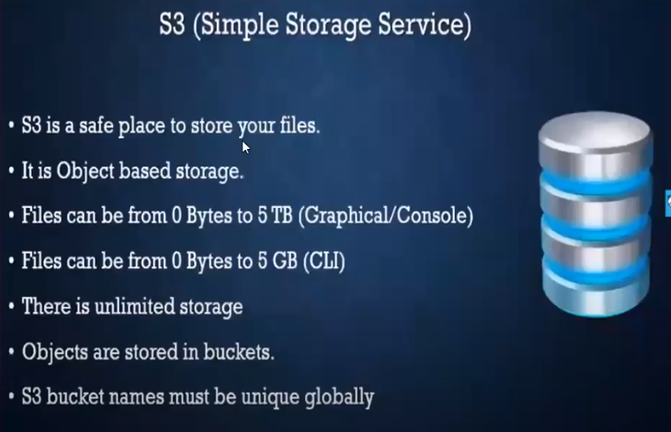

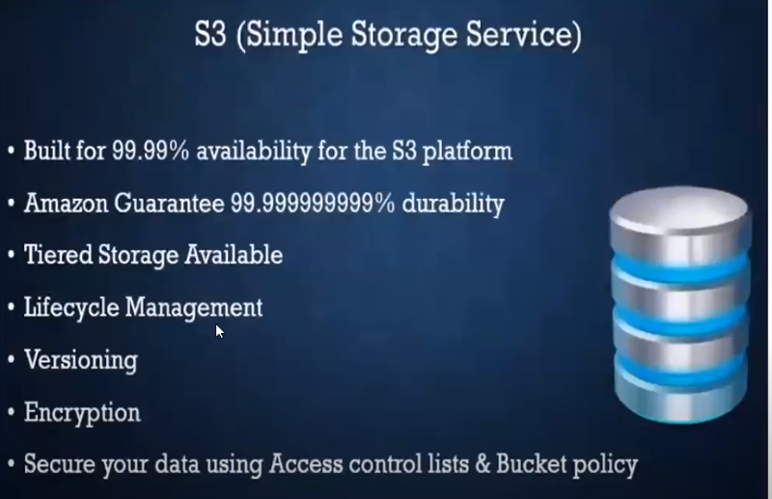

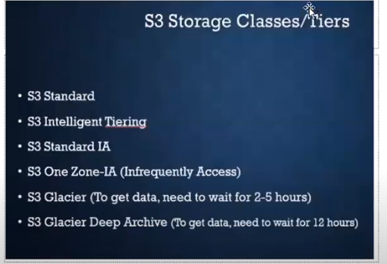

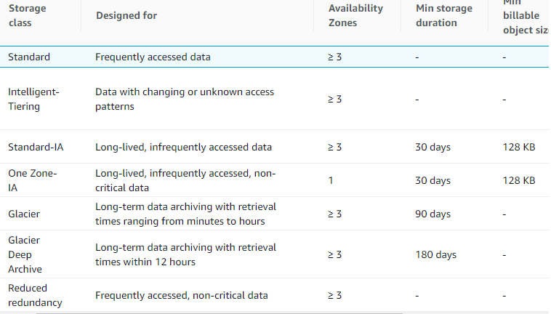

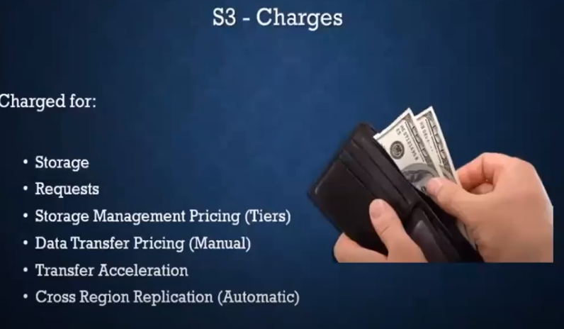

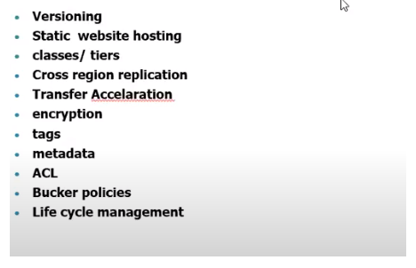

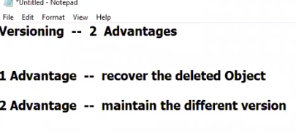

List versions for recovering the objects

Show versions for versioning the objects

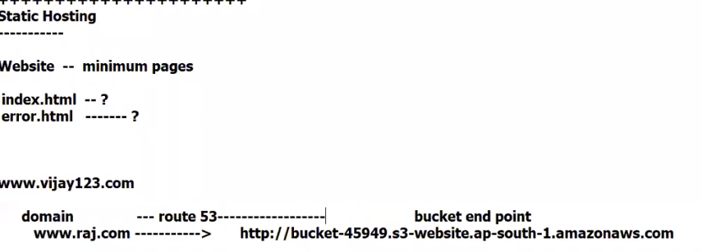



-----------------------------------------

Lets say, we have two buckets ( 1st bucket in mumbai

2nd bucket in sydney )

We we upload the object in mumbai, the object should also be available in sydney ).

As we are replicating an object in another region, it is called cross region replication.

vice-versa will not happen.

If we delete object in mumbai, it will not be deleted in sydney.

If we edit object in mumbai, it will not de edited in sydney.

Lets create bucket

bucket name - mumbai-sfsdfgds

Region - mumbai

Next ----> Next ---> uncheck block all public access

Next ---> create bucket.

Lets create 2nd bucket in sydney

Lets create bucket

bucket name - sydney-fhgfhfd

Region - sydney

Next ----> Next ---> uncheck block all public access

Next ---> create bucket.

Enable cross region replication in mumbai bucket

--------------------------------------------------

Select mumbai bucket --> Management ---> Replication Rules--> Create Replication Rule ---> Enable Bucket versioning ---> Replication Rule Name - CRR1

Destination bucket --> Sydney bucket --> Enable versioning ---> ---> IAM Role -->

( TO establish connection between two regions, we need role )

IAM Role - Create new role

Save.

Now, lets upload object in mumbai bucket, it will be replicated in sydney bucket!!!!



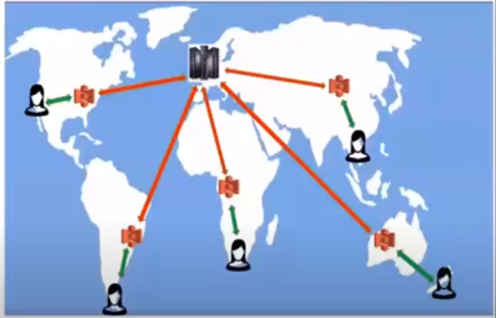

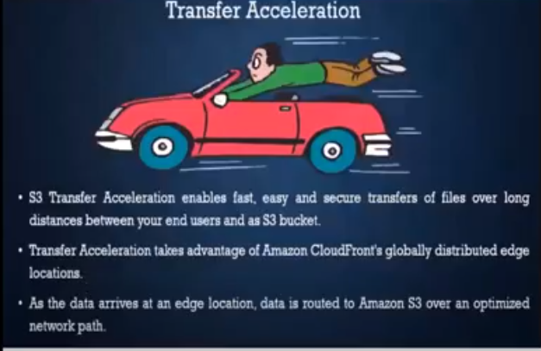

Transfer Acceleration

Properties -------> Transfer accelaration --> Learn More

Amazon S3 Transfer Acceleration Speed Comparison tool

---> want to compare your data transfer speed by region ( open in new tab )

we can compare

S3 direct upload speed

S3 acclerated transfer upload speed.

In this case, we cannot find much difference.

But in longer distances, we can find the difference.



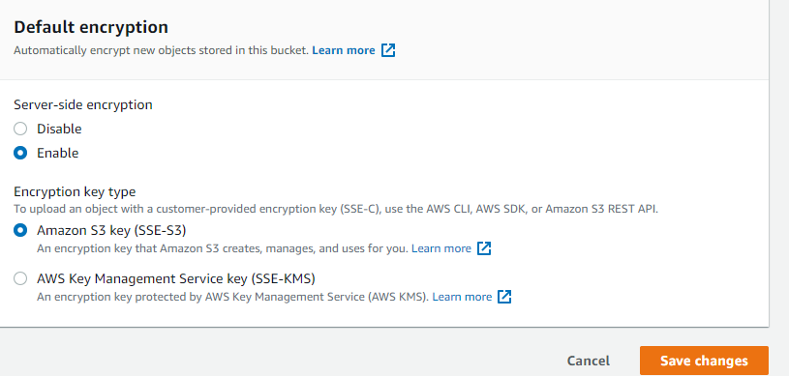

Encryption

----------------

There are two types of encryption

1) AES - 256 ( Advanced ENcryption standard ) - Single encryption

2) AWS - KMS ( Key management service ) - Double encryption ( More secured )

Select the required encryption.

Select the bucket -- Properties ---Default Encription -- Edit -- Enable

Metadata and Tags

Metadata -- To provide more information about the object in key-value pairs.

Keys are predefinied. eg: Content-type, Content-language etc

tags -- To provide more information about the object in key-value pairs.

Keys and values we need to provide.

Select the object ---> Properties, we can see the metadata and tags.



ACL and Bucket policy

------------------------

Select the bucket --> Permissions tab

ACL Edit -- Add grantee

Enter canonical ID -- Save Changes

Note: ACL we can apply at bucket level and object level

Select the Object and provide the access by entering canonical ID



